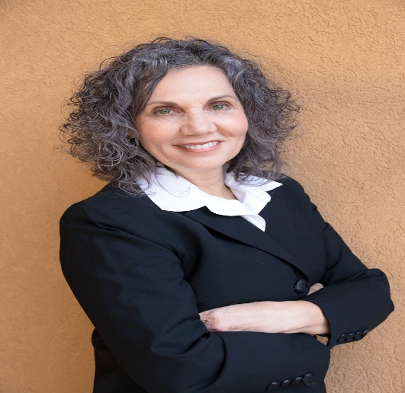

[Lynn Silipigni Connaway](http://www.oclc.org/research/people/connaway.html), Ph.D., is Director of Library Trends and User Research and leads the[**User Studies**](https://www.oclc.org/research/themes/user-studies.html)research at [OCLC Research](http://www.oclc.org/research.html). She is the Past President of the Association of Information Science & Technology (ASIS&T) and was the Chair of the American Library Association (ALA) Association of College and Research Libraries (ACRL) Value of Academic Libraries Committee. Lynn held the Chair of Excellence position at the Departmento de Biblioteconomía y Documentación at the Universidad Carlos III de Madrid, was a Visiting Researcher in the Department of Information Studies, University of Sheffield and a Visiting Scholar at the Royal School of Library and Information Science, Copenhagen, Denmark.

She has received research funding from the [IMLS](http://www.imls.gov/) in the US and [Jisc](http://www.jisc.ac.uk/) and the [Arts and Humanities Research Council](http://www.oclc.org/research/activities/recommender.html) in the UK. Lynn was the project lead on the ALA ACRL "[Action-Oriented Research Agenda on Library Contributions to Student Learning and Success](http://www.oclc.org/research/themes/user-studies/acrl-agenda.html)." Dr. Connaway is the co-author of the [4th](http://www.worldcat.org/title/basic-research-methods-for-librarians/oclc/55846881&referer=brief_results) and [5th](http://www.worldcat.org/title/basic-research-methods-for-librarians/oclc/804847313&referer=brief_results) editions of *Basic Research Methods* *for Librarians* and of the 6th edition, titled [*Research Methods in Library and Information Science*](http://www.worldcat.org/title/research-methods-in-library-and-information-science/oclc/1026248124&referer=brief_results).

Prior to joining OCLC Research, she was the Vice-President of Research and Library Systems at NetLibrary, the director of the Library and Information Services Department at the University of Denver, and on the faculty of the Library and Informational Science program at the University of Missouri, Columbia. To find out more about Dr. Connaway, visit <http://www.oclc.org/research/people/connaway.html>.